Feedback-to-Feature Studio
Project Description:
Feedback-to-Feature Studio is a Generative AI application that helps product teams turn scattered customer feedback - surveys, app reviews, support tickets and emails - into structured, actionable product opportunities. Rather than someone manually reading hundreds of feedback entries to spot trends, the system is designed to group recurring needs using semantic embeddings and clustering, ground its output in real product knowledge through Retrieval-Augmented Generation (RAG), and use an LLM to convert each recurring theme into a structured feature proposal - complete with the customer pain point, a user story, acceptance criteria and a priority.
The project is being built in phases, and this documentation covers the codebase as it stands at Phase 1: Project Foundation. The application already has a working Streamlit workspace with local account authentication, a real feedback dataset, and a live preprocessing-to-clustering pipeline that groups the demo feedback into themes on the Insights page. The Retrieval-Augmented Generation and LLM-based feature-proposal generation described in the project vision are represented by scaffolded modules and a demo interface on the Feature Lab page, ready for the AI-generation logic to be plugged in during the next phases.
Scenarios:
Scenario 1: A product manager creates a workspace account and signs in. Their password is hashed with a salted PBKDF2-HMAC-SHA256 scheme and stored in a local SQLite database, and they land on the Overview dashboard, which summarizes the workspace and highlights the top recurring themes.
Scenario 2: The product manager opens Feedback to search and filter the included 38-record demo dataset by keyword, source and product area, then opens Insights, where the application runs the actual preprocessing, embedding and clustering pipeline against that dataset and displays the resulting themes, ranked by how many feedback items belong to each one.
Scenario 3: The product manager opens Feature Lab, selects a theme such as Performance, and clicks Generate Feature Proposal. The current build returns a structured proposal - customer problem, customer need, proposed solution, priority, expected impact, a user story and acceptance criteria - built from a template for that theme, standing in for the RAG-grounded, Gemini-generated proposal planned for a later phase.
Technical Architecture:
Streamlit Frontend (app.py workspace shell)
↓
Local Authentication (SQLite users.db, PBKDF2-HMAC-SHA256)
↓
Preprocessing (modules/preprocessing.py)
↓
Embeddings (modules/embeddings.py - Sentence Transformers)
↓
Clustering & Theme Naming (modules/clustering.py - KMeans)
↓
RAG & LLM Feature Generation (modules/rag.py, modules/llm.py, modules/feature_generator.py - planned)

data/feedback.csv (38-record demo dataset) | data/knowledge_base.txt (fictional Nexora Analytics product knowledge) | data/users.db (local account store) | .env (LLM_PROVIDER, GEMINI_API_KEY)
Description:
The application follows a single-file Streamlit design centred on app.py, which renders every workspace page and calls out to the modules package for the analysis pipeline. init_database() provisions a local SQLite file (data/users.db) with a users table; hash_password() and verify_password() implement salted PBKDF2-HMAC-SHA256 hashing so no plaintext password is ever stored. load_feedback_data() reads the demo dataset from data/feedback.csv, and load_knowledge_base() reads the fictional product knowledge document from data/knowledge_base.txt, both defensively handling a missing or malformed file.
The core analysis pipeline lives in analyze_feedback(), a cached function that chains three modules together: preprocess_dataframe() cleans and normalizes the raw feedback text, generate_embeddings() converts the cleaned text into semantic vectors, and cluster_feedback() together with generate_theme_names() groups those vectors into themes and labels them. This pipeline is real and already runs against the demo dataset on the Insights page. The remaining planned modules - rag.py for retrieving relevant product knowledge and llm.py for calling the Gemini API - are not yet wired into app.py; the Feature Lab page currently demonstrates the intended output shape using a template-based proposal for each theme.
Key Functions & Modular Components:
- Preprocessing Module (modules.preprocessing.preprocess_dataframe): cleans and normalizes raw feedback text into a cleaned_feedback column ahead of embedding. Implemented and actively used by the Insights pipeline.
- Embeddings Module (modules.embeddings.generate_embeddings): converts cleaned feedback text into semantic vectors, planned around the Sentence Transformers all-MiniLM-L6-v2 model. Implemented and actively used by the Insights pipeline.
- Clustering Module (modules.clustering.cluster_feedback, generate_theme_names): groups feedback embeddings into themes with scikit-learn KMeans and generates a readable label for each cluster. Implemented and actively used by the Insights pipeline.
- RAG Module (modules.rag): planned to retrieve relevant passages from the product knowledge base (data/knowledge_base.txt) via FAISS or ChromaDB to ground feature generation in real product context. Present as a module scaffold; not yet called from app.py.
- LLM Module (modules.llm): planned to call the Google Gemini API (configured via LLM_PROVIDER and GEMINI_API_KEY in .env) to generate feature proposals from a theme and its retrieved context. Present as a module scaffold; not yet called from app.py.
- Feature Generator Module (modules.feature_generator): planned to orchestrate clustering, RAG retrieval and the LLM call into one structured feature proposal - pain point, user story, acceptance criteria and priority. Present as a module scaffold; the Feature Lab page currently uses a template-based proposal in its place.
- Shared Utilities (utils.helpers): shared helper functions supporting the modules above.
Pre-requisites:
- Python Programming Proficiency: Python Documentation
- Streamlit Framework Knowledge: Streamlit Documentation
- Semantic Embeddings with Sentence Transformers: Sentence Transformers Documentation
- Clustering with scikit-learn (KMeans): scikit-learn Documentation
- Vector Search with FAISS: FAISS Documentation
- Vector Search with ChromaDB: ChromaDB Documentation
- Google Gemini API Familiarity: Gemini API Documentation
- Gemini API Key Setup: Google AI Studio API Keys
- Pandas for Data Handling: pandas Documentation
- Environment Variable Handling: python-dotenv Documentation
- Version Control with Git: Git Documentation

Project Workflow:
Milestone 1: Project Foundation and Environment Setup
- Activity 1.1: Install the phase-based dependencies from requirements.txt.
- Activity 1.2: Configure the .env file for the Gemini LLM provider.
- Activity 1.3: Establish the project's folder structure.
Milestone 2: Demo Feedback Dataset and Product Knowledge Base
- Activity 2.1: Load the demo feedback dataset (data/feedback.csv).
- Activity 2.2: Load the fictional product knowledge base (data/knowledge_base.txt).
Milestone 3: Local Authentication with Salted Password Hashing
- Activity 3.1: Provision the SQLite users database.
- Activity 3.2: Hash and verify passwords with PBKDF2-HMAC-SHA256.
- Activity 3.3: Implement the login and account-creation flow.
Milestone 4: Text Preprocessing
- Activity 4.1: Clean and normalize raw feedback text with preprocess_dataframe().
Milestone 5: Semantic Embeddings
- Activity 5.1: Convert cleaned feedback into semantic vectors with generate_embeddings().
Milestone 6: Feedback Clustering and Theme Naming
- Activity 6.1: Group feedback embeddings into themes with cluster_feedback().
- Activity 6.2: Label each theme with generate_theme_names().
Milestone 7: Streamlit Application Shell and Cached Analysis Pipeline
- Activity 7.1: Configure the Streamlit page and apply the custom design system.
- Activity 7.2: Bootstrap authentication session state.
- Activity 7.3: Chain preprocessing, embeddings and clustering in analyze_feedback().
Milestone 8: Workspace Interfaces - Overview, Feedback and Insights
- Activity 8.1: Build the Overview dashboard.
- Activity 8.2: Build the Feedback inbox with search, filters and pagination.
- Activity 8.3: Build the Insights page on the live clustering pipeline.
Milestone 9: Feature Lab, Knowledge Base and Settings Pages
- Activity 9.1: Build the Feature Lab demo proposal generator.
- Activity 9.2: Build the Knowledge Base viewer.
- Activity 9.3: Build the Settings page.
Milestone 10: Deployment, Testing and Conclusion
- Activity 10.1: Run the application locally with Streamlit.
- Activity 10.2: Verify current end-to-end behavior.
Milestone 1: Project Foundation and Environment Setup
This milestone establishes the local environment the rest of the project builds on. The project's own requirements.txt is organized by the phase that introduces each dependency, which makes the project's current build stage explicit.
Activity 1.1: Install the Phase-Based Dependencies
requirements.txt groups its packages under phase headings. Phase 1 (Foundation), Phase 3 (Embeddings) and Phase 4 (Clustering) list active, installed packages. Phase 5 (RAG / Vector Store) and Phase 6 (LLM API) list their packages as comments, meaning those dependencies are documented but not yet added to the environment - a direct, code-level confirmation that RAG and LLM generation are still ahead in the project's roadmap.
# -- Phase 1: Foundation ------------------------------------------------
streamlit
pandas
python-dotenv

# -- Phase 3: Embeddings (add when implementing embeddings.py) ----------
sentence-transformers
numpy

# -- Phase 4: Clustering (add when implementing clustering.py) ----------
scikit-learn

# -- Phase 5: RAG / Vector Store (add one when implementing rag.py) -----
# faiss-cpu
# chromadb

# -- Phase 6: LLM API (add when implementing llm.py) --------------------
# google-generativeai
# openai <- optional, if OpenAI support is added later
requirements.txt - dependencies grouped by project phase
Activity 1.2: Configure the Gemini LLM Provider
.env.example documents the environment variables the planned LLM integration will read: which provider to use, the Gemini API key, an optional OpenAI key for a future alternative provider, and a debug flag. A developer copies this file to .env and fills in a real key ahead of implementing modules/llm.py.
# -- LLM Provider ---------------------------------------------------------
LLM_PROVIDER=gemini

# -- Google Gemini API ------------------------------------------------------
GEMINI_API_KEY=your_api_key_here

# -- OpenAI API (optional, if you want to support OpenAI as an alternative) -
# OPENAI_API_KEY=your_openai_key_here

# -- App Settings ------------------------------------------------------------
APP_DEBUG=false
.env.example - the environment variable template
Activity 1.3: Establish the Project's Folder Structure
The repository is organized so the Streamlit entrypoint, data, analysis modules and shared utilities each have a clear home, which is what lets app.py import the pipeline functions by name.
Feedback-to-Feature-Studio/
|-- app.py <- Streamlit application entry point
|
|-- data/
| |-- feedback.csv <- Demo feedback dataset (38 records)
| `-- knowledge_base.txt <- Fictional product knowledge base
|
|-- modules/
| |-- preprocessing.py <- Text cleaning & normalization
| |-- embeddings.py <- Semantic embedding generation
| |-- clustering.py <- KMeans-based feedback clustering
| |-- rag.py <- Knowledge retrieval (RAG)
| |-- llm.py <- LLM API communication
| `-- feature_generator.py <- Feature proposal orchestration
|
|-- utils/
| `-- helpers.py <- Shared utility functions
|
|-- .env.example <- Environment variable template
`-- requirements.txt
The project's folder structure, as laid out in README.md
Milestone 2: Demo Feedback Dataset and Product Knowledge Base
Two local data files stand in for the multiple live feedback channels (surveys, reviews, emails, support tickets) and the product documentation described in the project's purpose, so the rest of the pipeline has real content to run against during development.
Activity 2.1: Load the Demo Feedback Dataset
data/feedback.csv holds 38 demo feedback records spanning 7 themes. load_feedback_data() reads it with pandas and checks for the four required columns - id, source, feedback and product_area. If the file is missing, empty, malformed, or missing a required column, the function returns an empty DataFrame with the expected columns rather than raising an error, so the rest of the workspace can still render.
def load_feedback_data():
required_columns = {"id", "source", "feedback", "product_area"}
try:
feedback_df = pd.read_csv("data/feedback.csv")
except FileNotFoundError:
return pd.DataFrame(columns=sorted(required_columns))
except (pd.errors.EmptyDataError, pd.errors.ParserError):
return pd.DataFrame(columns=sorted(required_columns))

missing_columns = required_columns.difference(feedback_df.columns)
if missing_columns:
return pd.DataFrame(columns=sorted(required_columns))

return feedback_df
app.py - load_feedback_data(): reading the demo dataset defensively
Activity 2.2: Load the Product Knowledge Base
data/knowledge_base.txt documents a fictional product, Nexora Analytics, so the planned RAG module has real product context to retrieve from once it is wired in. load_knowledge_base() reads the file as plain text and is cached with @st.cache_data; if the file cannot be read, it returns a placeholder message instead of failing.
@st.cache_data
def load_knowledge_base():
"""Load the local product knowledge document without changing it."""
knowledge_path = PROJECT_ROOT / "data" / "knowledge_base.txt"
try:
return knowledge_path.read_text(encoding="utf-8")
except OSError:
return "The product knowledge document is currently unavailable."
app.py - load_knowledge_base(): reading the product knowledge document
Milestone 3: Local Authentication with Salted Password Hashing
Workspace access is gated by a self-contained authentication layer built directly in app.py, backed by a local SQLite database rather than an external identity provider.
Activity 3.1: Provision the SQLite Users Database
init_database() creates data/users.db and a users table if they do not already exist, and is called once when the module loads, so the schema is always ready before the login screen is shown.
def init_database():
"""Create the local SQLite authentication database and users table."""
DATABASE_PATH.parent.mkdir(parents=True, exist_ok=True)
with sqlite3.connect(DATABASE_PATH) as connection:
connection.execute(
"""
CREATE TABLE IF NOT EXISTS users (
id INTEGER PRIMARY KEY AUTOINCREMENT,
name TEXT NOT NULL,
email TEXT UNIQUE NOT NULL,
password_hash TEXT NOT NULL,
created_at TEXT NOT NULL
)
"""
)
app.py - init_database(): provisioning the local users table
Activity 3.2: Hash and Verify Passwords
hash_password() generates a random 16-byte salt and runs PBKDF2-HMAC-SHA256 over the password with 300,000 iterations, storing the algorithm name, iteration count, salt and digest together in one string. verify_password() re-derives the digest from the stored salt and iteration count and compares it to the stored digest using hmac.compare_digest(), a constant-time comparison that resists timing attacks.
PASSWORD_ITERATIONS = 300_000

def hash_password(password):
"""Return a salted PBKDF2-HMAC-SHA256 password hash."""
salt = secrets.token_bytes(16)
digest = hashlib.pbkdf2_hmac(
"sha256", password.encode("utf-8"), salt, PASSWORD_ITERATIONS,
)
return f"pbkdf2_sha256${PASSWORD_ITERATIONS}${salt.hex()}${digest.hex()}"

def verify_password(password, stored_hash):
"""Safely compare a password with a stored salt and hash."""
try:
algorithm, iterations, salt_hex, digest_hex = stored_hash.split("$")
if algorithm != "pbkdf2_sha256":
return False
candidate = hashlib.pbkdf2_hmac(
"sha256", password.encode("utf-8"),
bytes.fromhex(salt_hex), int(iterations),
).hex()
return hmac.compare_digest(candidate, digest_hex)
except (ValueError, TypeError):
return False
app.py - salted PBKDF2-HMAC-SHA256 hashing and constant-time verification
Activity 3.3: Login and Account Creation
create_user() normalizes the name and email, hashes the password, and inserts the new account, returning False if the email already exists (caught via the users table's UNIQUE constraint through sqlite3.IntegrityError). get_user() fetches an account by normalized email for the login form to verify against. valid_email() applies a simple regular-expression check during sign-up, and logout_user() clears every authentication-related key from session state, including which workspace page was active.
def create_user(name, email, password):
"""Insert a new account, returning False when the email already exists."""
try:
with sqlite3.connect(DATABASE_PATH) as connection:
connection.execute(
"INSERT INTO users (name, email, password_hash, created_at) "
"VALUES (?, ?, ?, ?)",
(name.strip(), email.strip().lower(), hash_password(password),
datetime.now(timezone.utc).isoformat()),
)
return True
except sqlite3.IntegrityError:
return False
app.py - create_user(): inserting a new account with a hashed password
Milestone 4: Text Preprocessing
modules/preprocessing.py is the first stage of the analysis pipeline. Its internal implementation sits inside the modules package, which was not among the files retrievable for this documentation, so this milestone documents the module by its confirmed role in the pipeline rather than its internal code.
Activity 4.1: Clean and Normalize Feedback Text
app.py imports preprocess_dataframe() from modules.preprocessing and calls it as the first step of analyze_feedback(), passing in the raw feedback DataFrame loaded from data/feedback.csv. Its output is expected to add a cleaned_feedback column, since that is exactly the column generate_embeddings() is called on immediately afterward. When the incoming DataFrame is empty, analyze_feedback() short-circuits before calling any further pipeline stage and returns an empty result with cluster and theme columns already typed.
from modules.preprocessing import preprocess_dataframe

@st.cache_data(show_spinner="Analyzing customer feedback...")
def analyze_feedback(feedback_df):
"""Preprocess, embed, cluster, and label feedback in memory."""
analyzed = preprocess_dataframe(feedback_df)
if analyzed.empty:
analyzed["cluster"] = pd.Series(dtype="int64")
analyzed["theme"] = pd.Series(dtype="object")
return analyzed
...
app.py - preprocess_dataframe() as the first stage of analyze_feedback()
Milestone 5: Semantic Embeddings
modules/embeddings.py is the second pipeline stage. As with preprocessing, its internal source was not retrievable, so it is documented here by its confirmed call signature and the model the README's Planned Technologies table names for this role.
Activity 5.1: Convert Feedback into Semantic Vectors
generate_embeddings() is imported from modules.embeddings and called on the list of cleaned feedback strings produced by preprocessing. The project's README names the Sentence Transformers all-MiniLM-L6-v2 model for this role, which is why sentence-transformers appears as an active Phase 3 dependency in requirements.txt. Working with semantic vectors rather than raw keywords is what lets the next stage group feedback that uses different wording for the same underlying need.
from modules.embeddings import generate_embeddings

embeddings = generate_embeddings(analyzed["cleaned_feedback"].tolist())
app.py - calling generate_embeddings() on the cleaned feedback text
Milestone 6: Feedback Clustering and Theme Naming
modules/clustering.py is the third pipeline stage and the one whose output is directly visible in the workspace: the themes shown on the Insights page are its result.
Activity 6.1: Group Feedback into Themes
cluster_feedback() is imported from modules.clustering and called on the embeddings produced by the previous stage, returning a cluster label for every feedback item. The README's Planned Technologies table names scikit-learn KMeans for this role, matching scikit-learn's presence as an active Phase 4 dependency in requirements.txt.
from modules.clustering import cluster_feedback, generate_theme_names

labels, _ = cluster_feedback(embeddings)
app.py - clustering the embeddings into theme labels
Activity 6.2: Name Each Theme
generate_theme_names() takes the analyzed DataFrame and the cluster labels and returns a readable name for each cluster (for example, "Performance" or "Notifications"), which analyze_feedback() then maps back onto every row as a theme column alongside the numeric cluster id.
theme_names = generate_theme_names(analyzed, labels)

analyzed["cluster"] = labels
analyzed["theme"] = [theme_names[int(label)] for label in labels]
return analyzed
app.py - completing analyze_feedback() with named themes
Milestone 7: Streamlit Application Shell and Cached Analysis Pipeline
app.py is a single-file Streamlit application. This milestone covers its page configuration, custom design system, session-state bootstrap, and the caching that keeps the pipeline fast.
Activity 7.1: Page Configuration and Custom Styling
The page is configured once at import time, and a large block of custom CSS is injected via st.markdown(..., unsafe_allow_html=True) to theme the workspace with a dark, glass-panel design system - custom colors, the auth screen's animated feedback-node visual, metric cards, theme cards and opportunity cards - well beyond Streamlit's default look.
st.set_page_config(
page_title="Feedback-to-Feature Studio",
page_icon="✦",
layout="wide",
initial_sidebar_state="collapsed",
)
app.py - Streamlit page configuration
Activity 7.2: Session State Bootstrap
Five session-state variables are initialized if absent: authenticated, auth_mode (login or signup), user_name, user_email, and auth_message (used to show a one-time success notice after account creation, such as after signing up). active_page, which tracks the current workspace page, is initialized separately once the user is authenticated.
if "authenticated" not in st.session_state:
st.session_state.authenticated = False
if "auth_mode" not in st.session_state:
st.session_state.auth_mode = "login"
if "user_name" not in st.session_state:
st.session_state.user_name = ""
if "user_email" not in st.session_state:
st.session_state.user_email = ""
if "auth_message" not in st.session_state:
st.session_state.auth_message = None
app.py - session state bootstrap
Activity 7.3: Caching the Pipeline
analyze_feedback() is decorated with @st.cache_data(show_spinner="Analyzing customer feedback..."), so the preprocessing, embedding and clustering chain only runs when the underlying feedback DataFrame actually changes, rather than on every Streamlit rerun. load_knowledge_base() is similarly cached with @st.cache_data, since the product knowledge document does not change during a session.
Milestone 8: Workspace Interfaces - Overview, Feedback and Insights
Milestone 8 covers the three pages a signed-in user sees first, moving from a static workspace summary to the live output of the clustering pipeline.
Activity 8.1: Overview Dashboard
show_dashboard() greets the signed-in user and displays four illustrative summary metrics (Total Feedback, Recurring Themes, Feature Ideas, High Priority), a short list of recent activity, and a snapshot of top themes with progress bars. These values are currently fixed, illustrative figures written directly in app.py rather than being computed from the live dataset - the Insights page, covered next, is where the real pipeline output is shown. Three quick-action buttons route into Feedback, Insights and Feature Lab.
metrics = [
("TOTAL FEEDBACK", "38", "rgba(106,167,255,.2)"),
("RECURRING THEMES", "7", "rgba(65,212,195,.18)"),
("FEATURE IDEAS", "12", "rgba(158,123,255,.2)"),
("HIGH PRIORITY", "4", "rgba(239,101,122,.18)"),
]
app.py - show_dashboard(): the Overview page's illustrative summary metrics
Activity 8.2: Feedback Inbox
show_feedback_page() lists the demo dataset as a searchable, filterable, paginated card grid: a text search across the feedback column, a Source filter and a Product area filter, six cards per page, and Previous/Next controls. Changing any filter resets pagination back to page 1 via a filter-signature check stored in session state. An Upload Feedback button is present but currently shows a message that upload will be enabled in a later stage, consistent with the project's phased build.
Activity 8.3: Customer Insights
show_insights_page() is where the real pipeline output appears. It calls analyze_feedback() on the loaded dataset, then derives its metrics and charts entirely from that result: total feedback, the number of distinct themes found, a progress-bar card per theme sized by mention count, and a theme-detail panel that lists every feedback item belonging to the theme currently selected in a dropdown, along with its most common product area.
analyzed_df = analyze_feedback(feedback_df)
total_feedback = len(analyzed_df)
theme_counts = (analyzed_df["theme"].value_counts()
.sort_values(ascending=False)) if total_feedback else ...
app.py - show_insights_page(): metrics and charts driven by the live pipeline
Milestone 9: Feature Lab, Knowledge Base and Settings Pages
Milestone 9 covers the three remaining pages: the interface that previews the project's core AI deliverable, the product knowledge viewer the planned RAG module will read from, and workspace settings.
Activity 9.1: Feature Lab
show_feature_lab_page() lets a user pick one of six themes and click Generate Feature Proposal. The current build does not call an LLM: it looks the selected theme up in a hardcoded dictionary of six prepared proposals, each with a title, customer problem, customer need, proposed solution, priority and expected impact, and pairs it with a templated user story and a fixed three-item acceptance-criteria list. This page defines the exact output shape - problem, need, solution, priority, impact, user story, acceptance criteria - that modules/feature_generator.py, modules/rag.py and modules/llm.py are intended to produce dynamically once implemented.
proposals = {
"Performance": {
"title": "Faster Dashboard Experience",
"problem": "Users wait too long for dashboard information.",
"need": "Customers need a fast, dependable view of their most
important data.",
"solution": "Improve dashboard loading and prioritize key
information for the first view.",
"priority": "High",
"impact": "Reduce waiting during daily workflows and improve
confidence in the dashboard.",
},
...
}
app.py - show_feature_lab_page(): the current template-based proposal set
Activity 9.2: Knowledge Base
show_knowledge_page() displays the loaded product knowledge document inside an expandable viewer, alongside four description cards (Product Overview, Current Capabilities, Known Limitations, Supported Platforms). An Upload Knowledge button shows a message that document processing is not yet enabled - this is the document the planned RAG module (modules/rag.py) is intended to index and retrieve from once implemented.
Activity 9.3: Settings
show_settings_page() shows the signed-in user's profile (name and email), a fixed appearance summary, and an AI Configuration card whose Status field reads "Coming in the next stage" - a direct, in-product acknowledgment that the LLM integration is not active yet - plus an account/session summary card and a logout control.
Milestone 10: Deployment, Testing and Conclusion
The final milestone covers running the application locally and verifying what is currently implemented, end to end.
Activity 10.1: Run the Application Locally
With a virtual environment created and activated and dependencies installed, the application is launched with Streamlit:
python -m venv .venv
.venv\Scripts\Activate.ps1 # Windows (PowerShell)
source .venv/bin/activate # macOS / Linux

pip install -r requirements.txt

cp .env.example .env # then fill in GEMINI_API_KEY

streamlit run app.py
Creating the environment, installing dependencies and running the application
Streamlit starts a local development server (by default at http://localhost:8501) and opens the application in the browser. On first load, init_database() has already provisioned data/users.db, and the authentication screen is shown.
Activity 10.2: Verify Current End-to-End Behavior
- Authentication check: create an account, confirm a duplicate email is rejected, sign out, and sign back in with the same credentials.
- Feedback check: confirm search, the Source filter and the Product area filter narrow the 38-record dataset correctly, and that pagination resets when a filter changes.
- Insights check: confirm the theme cards and theme-detail panel reflect the actual output of analyze_feedback() rather than the Overview page's fixed figures.
- Feature Lab check: confirm each of the six themes returns its own template-based proposal, and note that no live LLM call occurs yet.
- Knowledge Base check: confirm the Nexora Analytics knowledge document renders in the viewer.
- Missing-data handling: temporarily rename data/feedback.csv and confirm the Feedback and Insights pages show an empty-state warning instead of crashing.
Exploring the Application's Pages:
1. Login / Sign Up
An animated hero panel introduces the product alongside a Login / Create account card. Login verifies the submitted email and password against the PBKDF2 hash stored in data/users.db. Sign Up collects a full name, work email, password and confirmation, validates the email format and matching passwords, and rejects an email that is already registered.
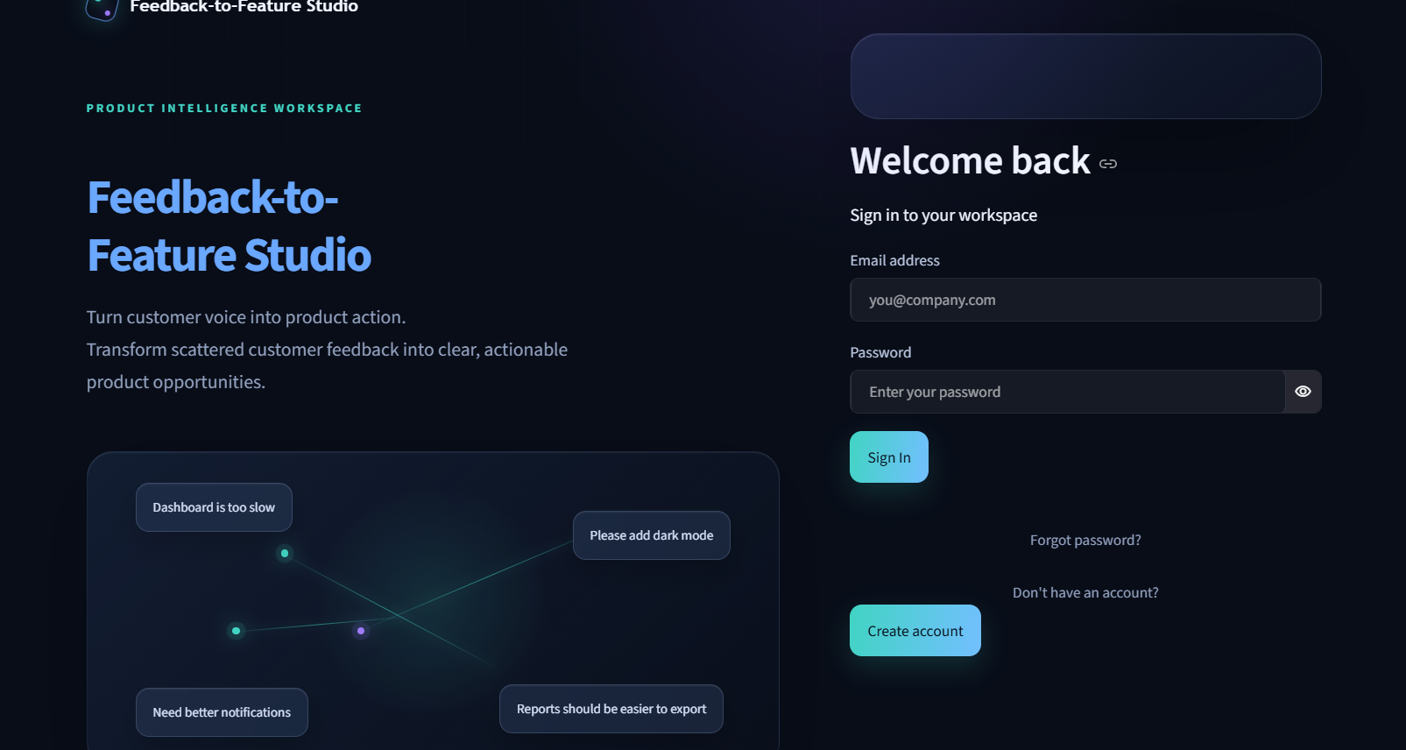
2. Overview
The workspace landing page. Shows four illustrative summary metrics, a short recent-activity feed, a snapshot of top themes, and quick-action buttons into Feedback, Insights and Feature Lab. 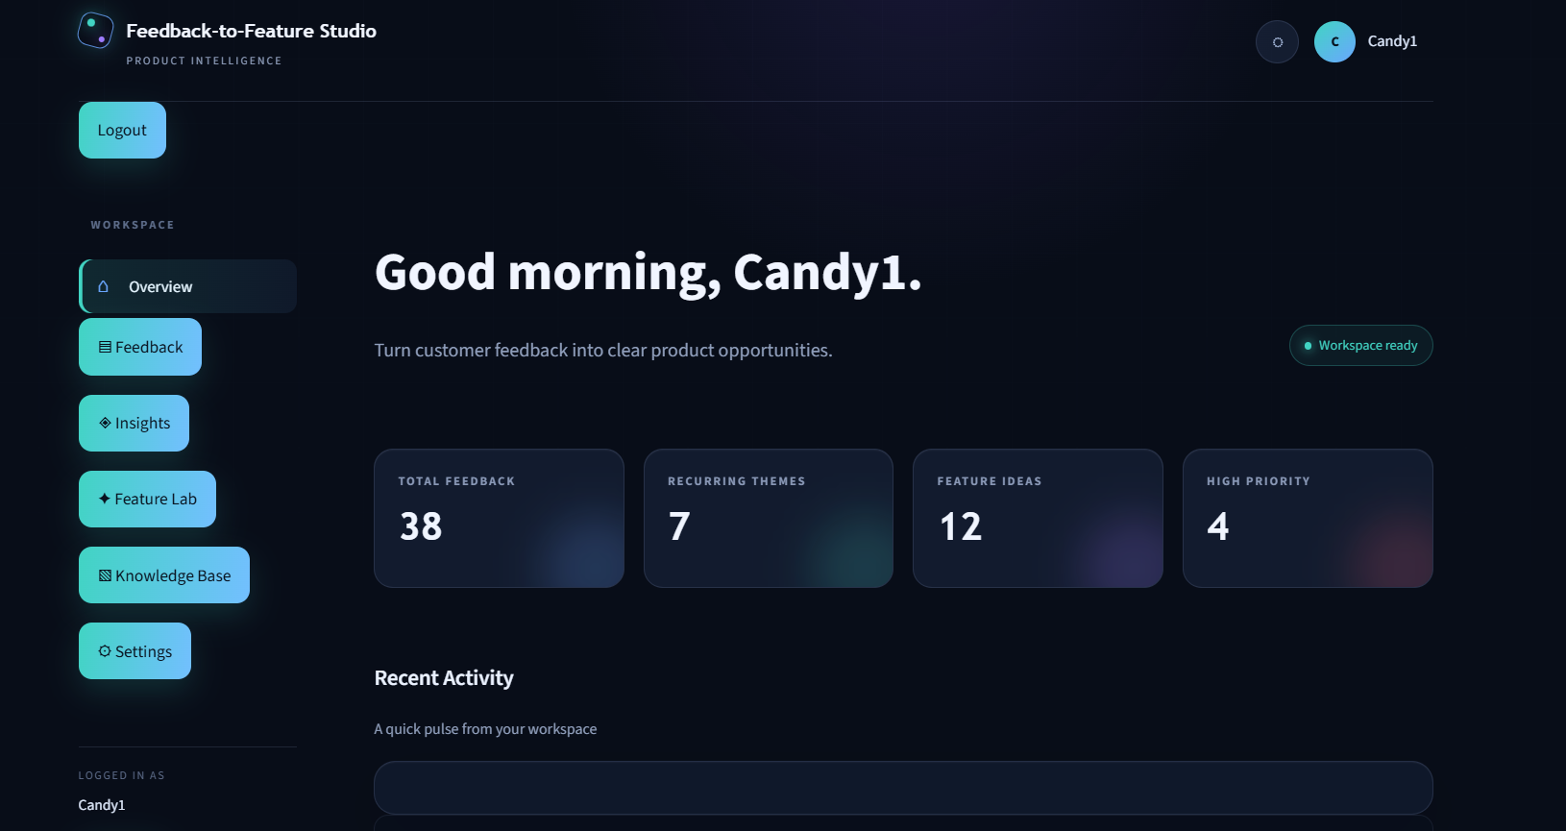
3. Feedback
A searchable, filterable card view of the 38-record demo dataset, with a text search box, Source and Product area filters, and paginated results six cards at a time.
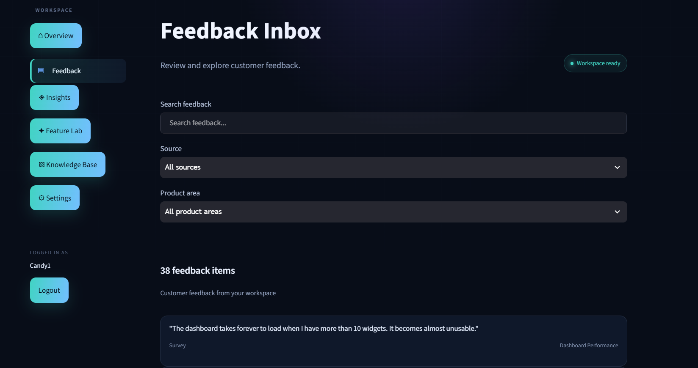

4. Insights
The page driven by the real pipeline: preprocessing, embeddings and clustering run against the loaded dataset, and the results are shown as theme cards with mention counts and percentages, plus a theme-detail panel listing every feedback item in the selected theme.
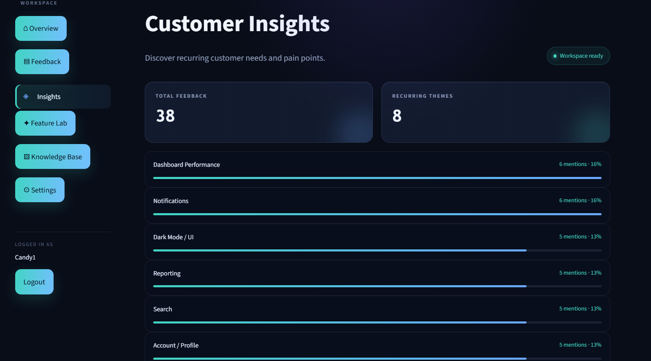
5. Feature Lab
Lets a user pick a theme and generate a structured feature proposal - problem, need, solution, priority, impact, user story and acceptance criteria. Currently returns a prepared, template-based proposal per theme rather than a live, RAG-grounded LLM generation.
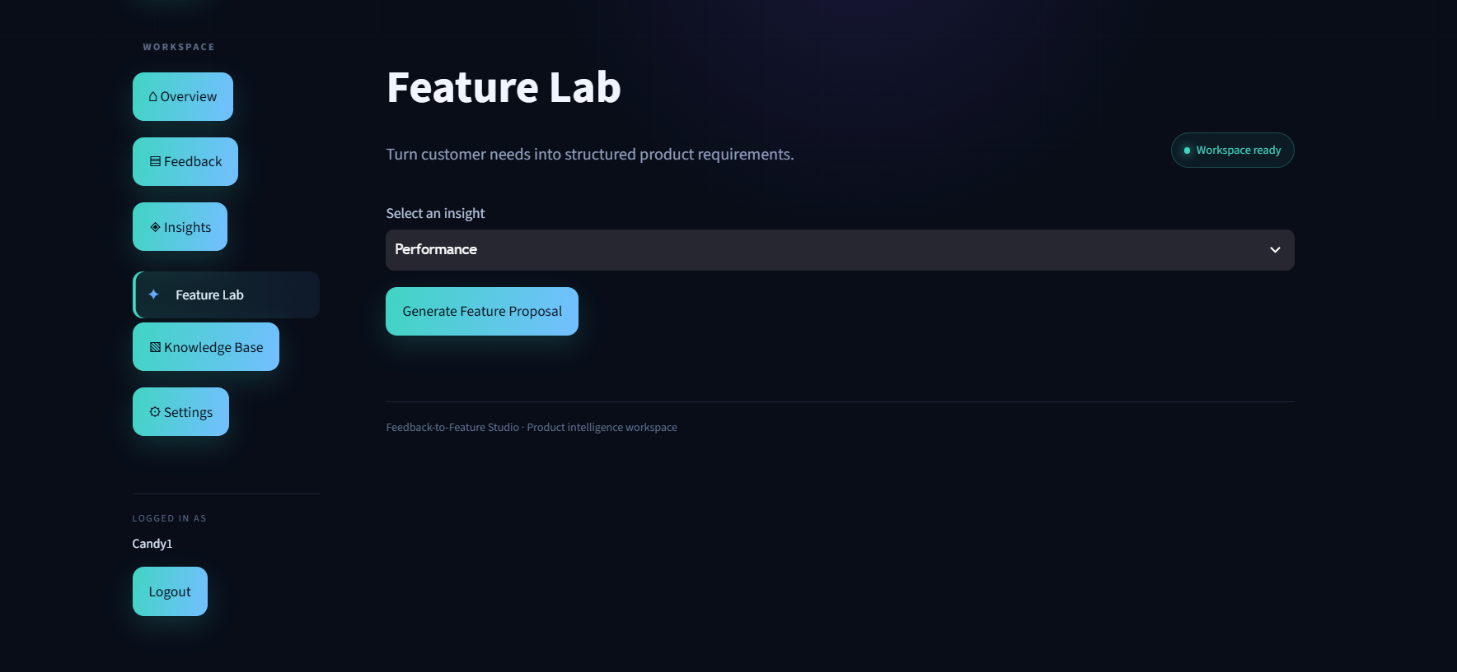
6. Knowledge Base
Displays the fictional Nexora Analytics product knowledge document that the planned RAG module is intended to retrieve from, alongside summary cards describing the product's overview, current capabilities, known limitations and supported platforms.
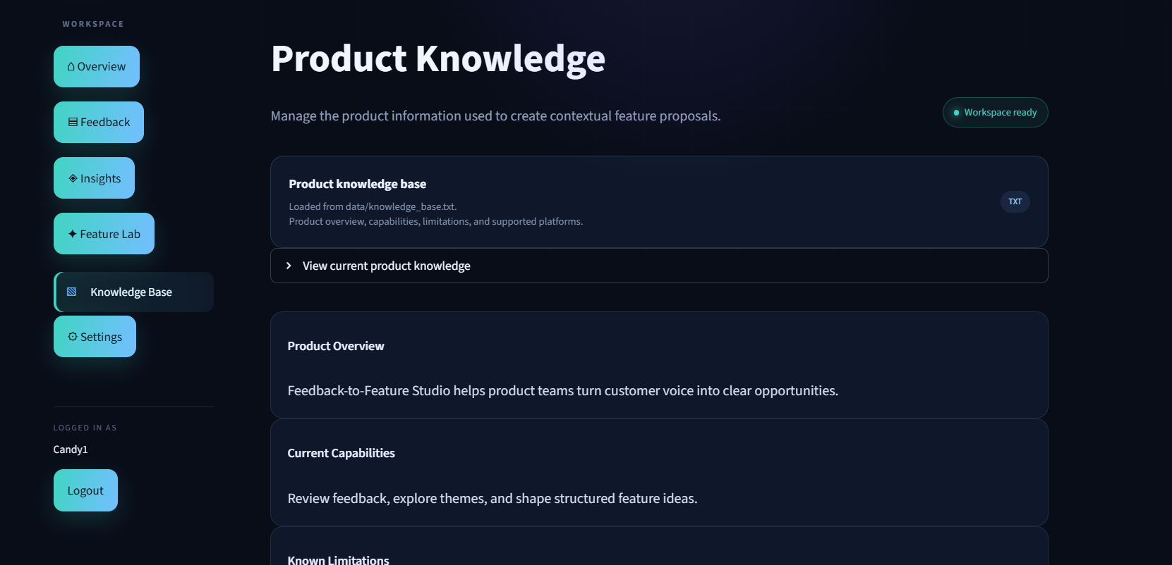
7. Settings
Shows the signed-in user's profile, workspace appearance, an AI Configuration card that currently reports the integration as not yet active, and account/session details. 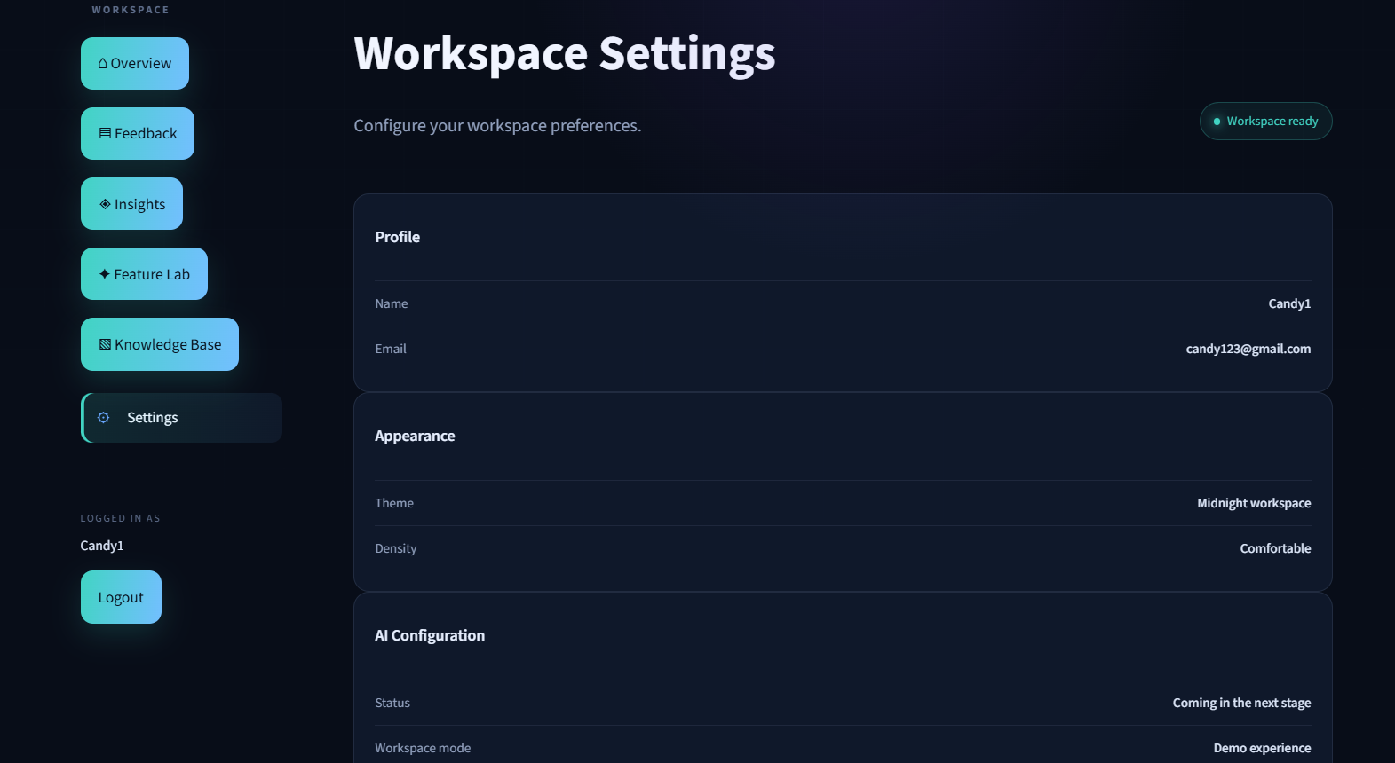
Conclusion:
Feedback-to-Feature Studio sets out to solve a real product-management problem: teams collect feedback from many channels but struggle to turn it into well-defined product requirements. The intended solution - semantic embeddings to understand feedback by meaning, clustering to group it into themes, Retrieval-Augmented Generation to ground output in real product knowledge, and an LLM to write the resulting feature proposals - is laid out clearly in the project's architecture and reflected in its module structure.
At its current stage, Phase 1: Project Foundation, the project already delivers a working, styled Streamlit workspace with local salted-password authentication, a real demo feedback dataset and product knowledge base, and a genuine preprocessing-to-clustering pipeline that groups feedback into themes live on the Insights page. The Feature Lab, Knowledge Base and Settings pages make the project's next steps concrete: they show exactly what a RAG-grounded, LLM-generated feature proposal should look like, and where the retrieval and generation logic will plug in once modules/rag.py and modules/llm.py move from scaffolds to implementations.

